5:49

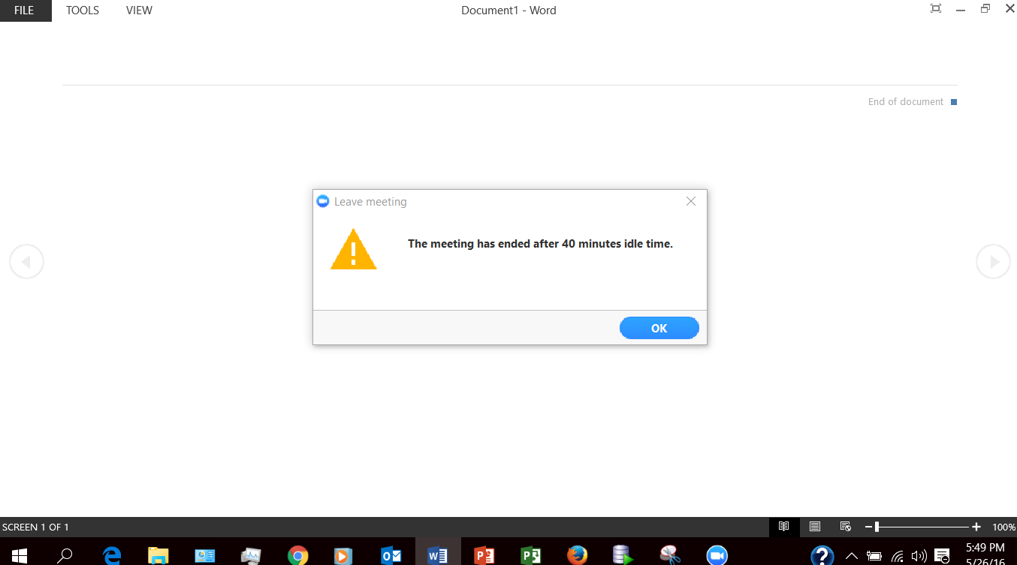

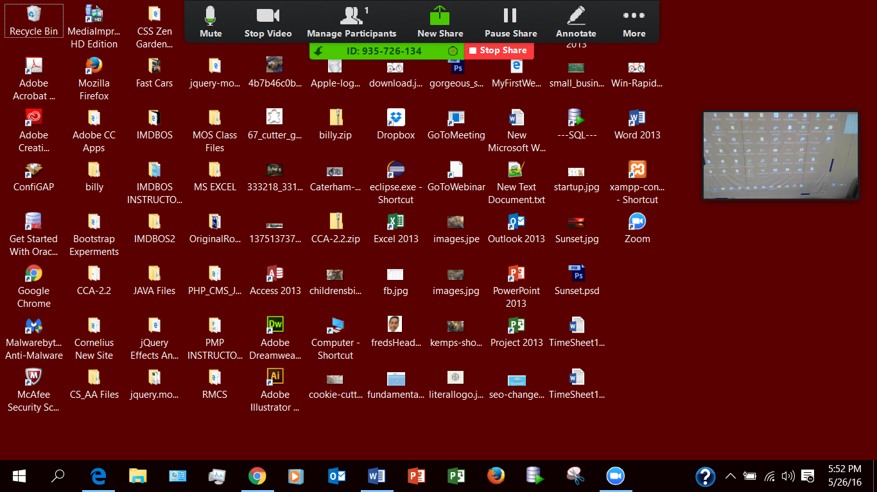

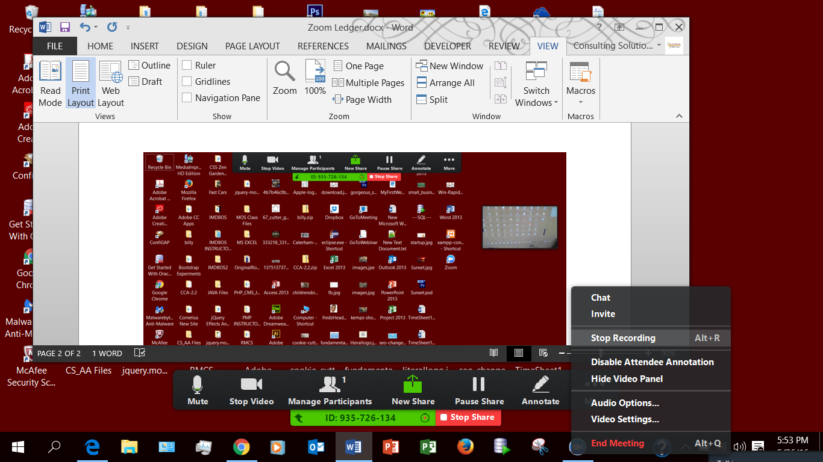

5/26 5:25 Moving file to Dropbox. Momentary Internet connection unstable message. Could not clip it in time.